Practical 3

Step 1 : Login to Salesforce Developers edition

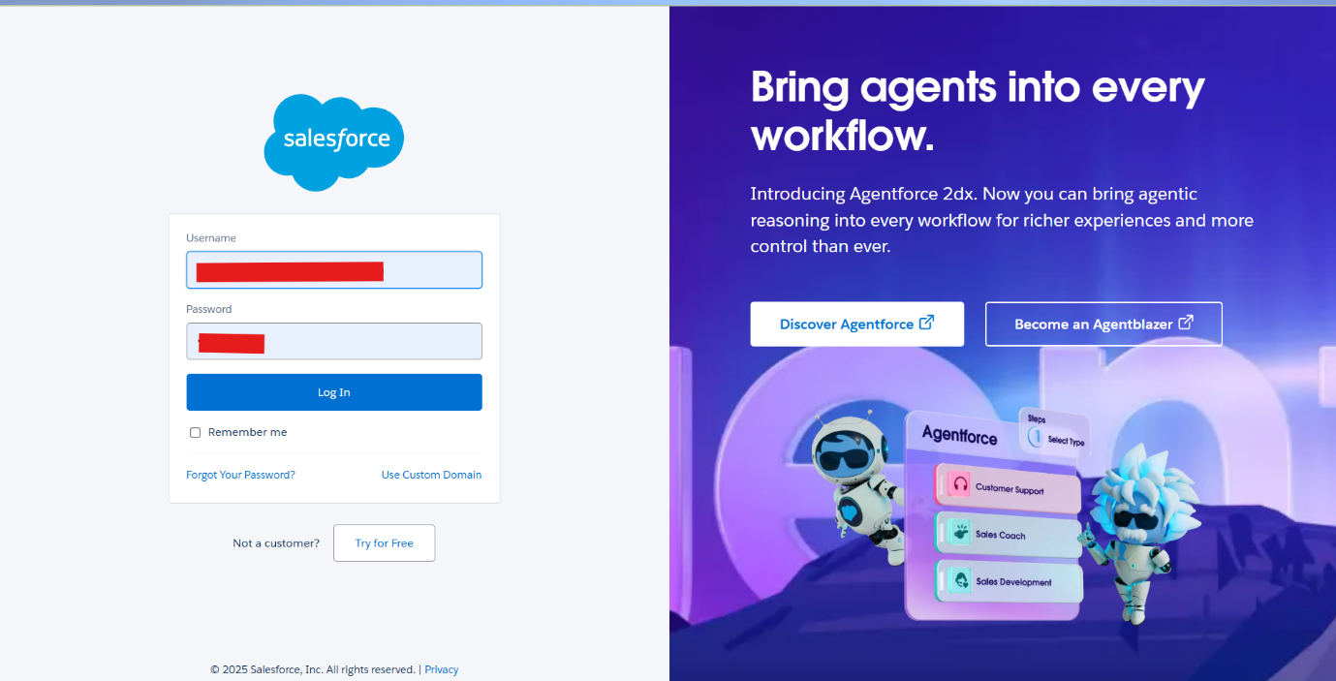

Step 2 : Click on the Setup button and then click on Developers console

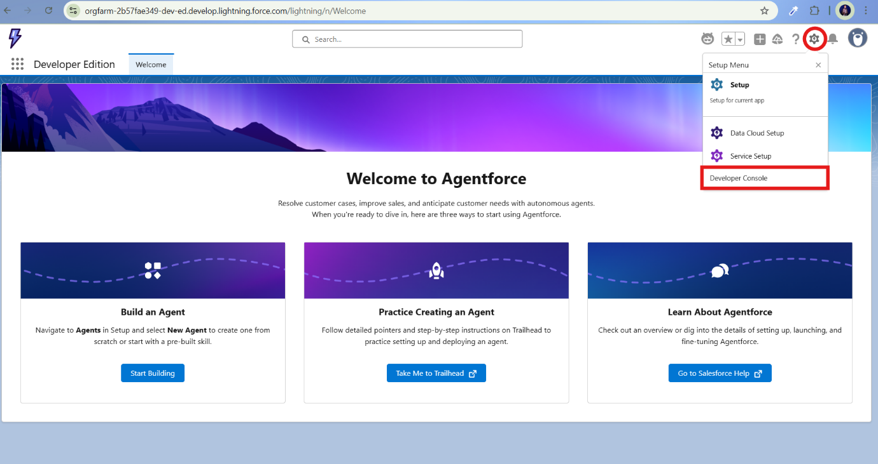

Step 3 : Click on file -> New -> Apex Class

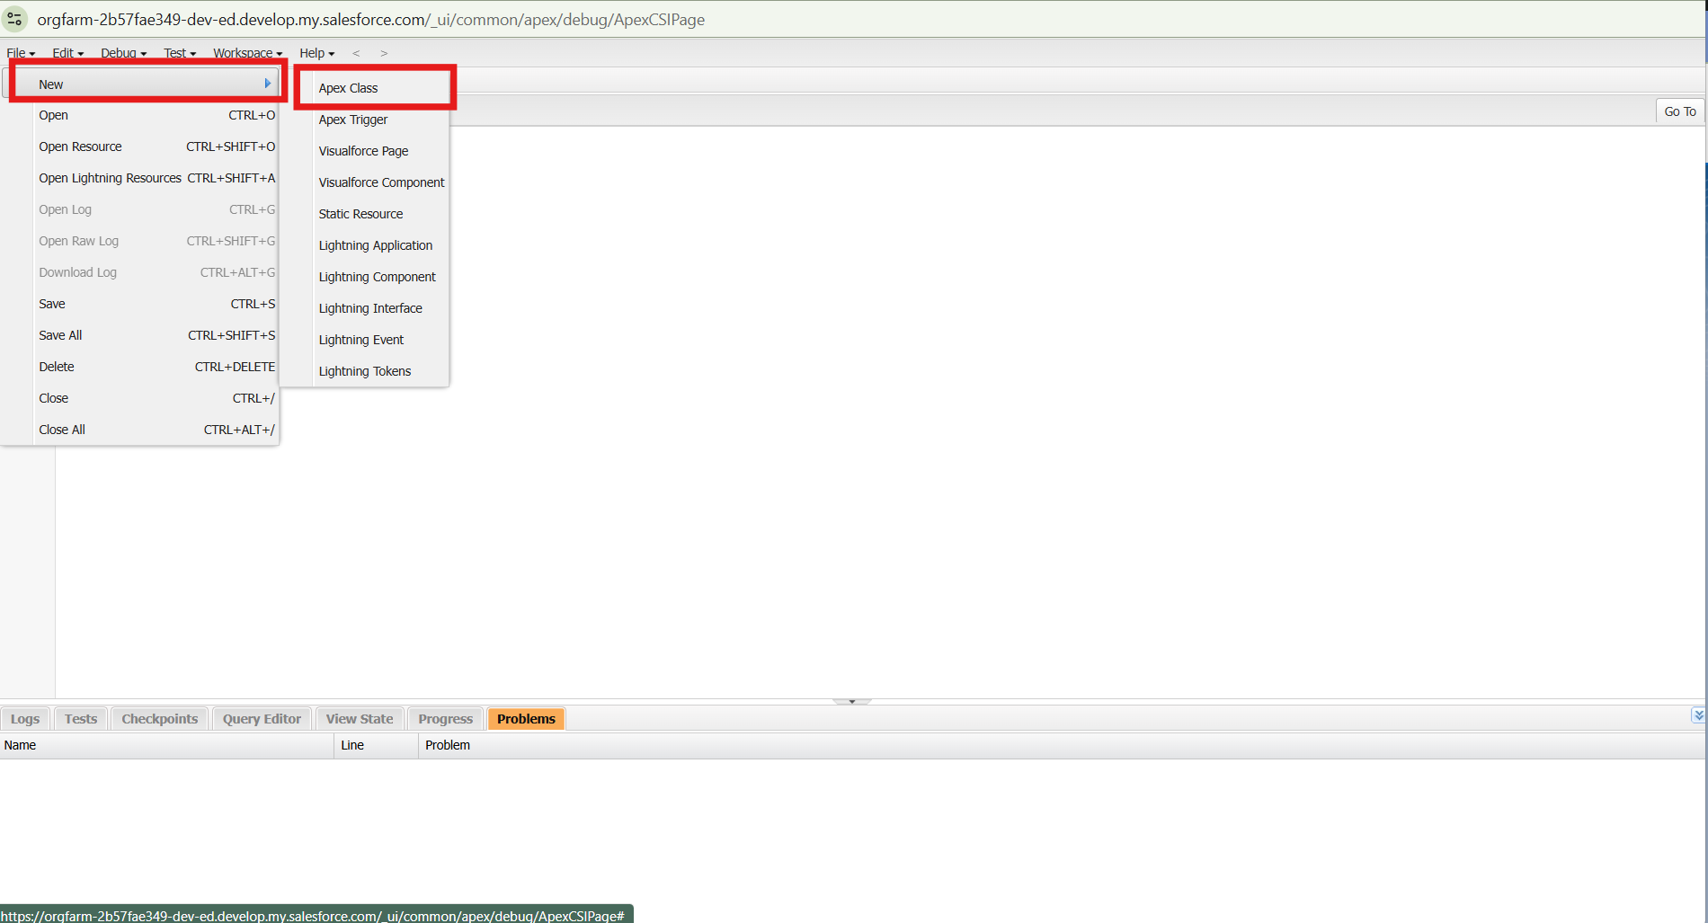

Step 4 : Enter a name for the apex class

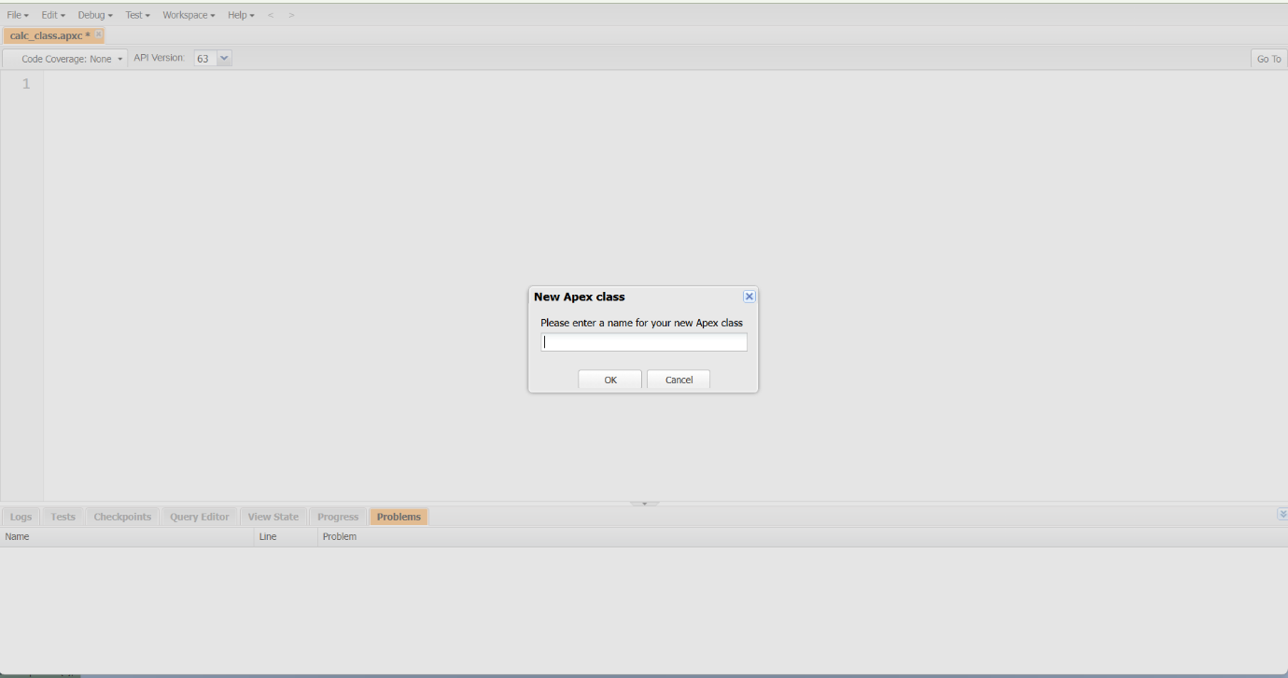

Step 5 : Write the code for Apex class & then save it and close it

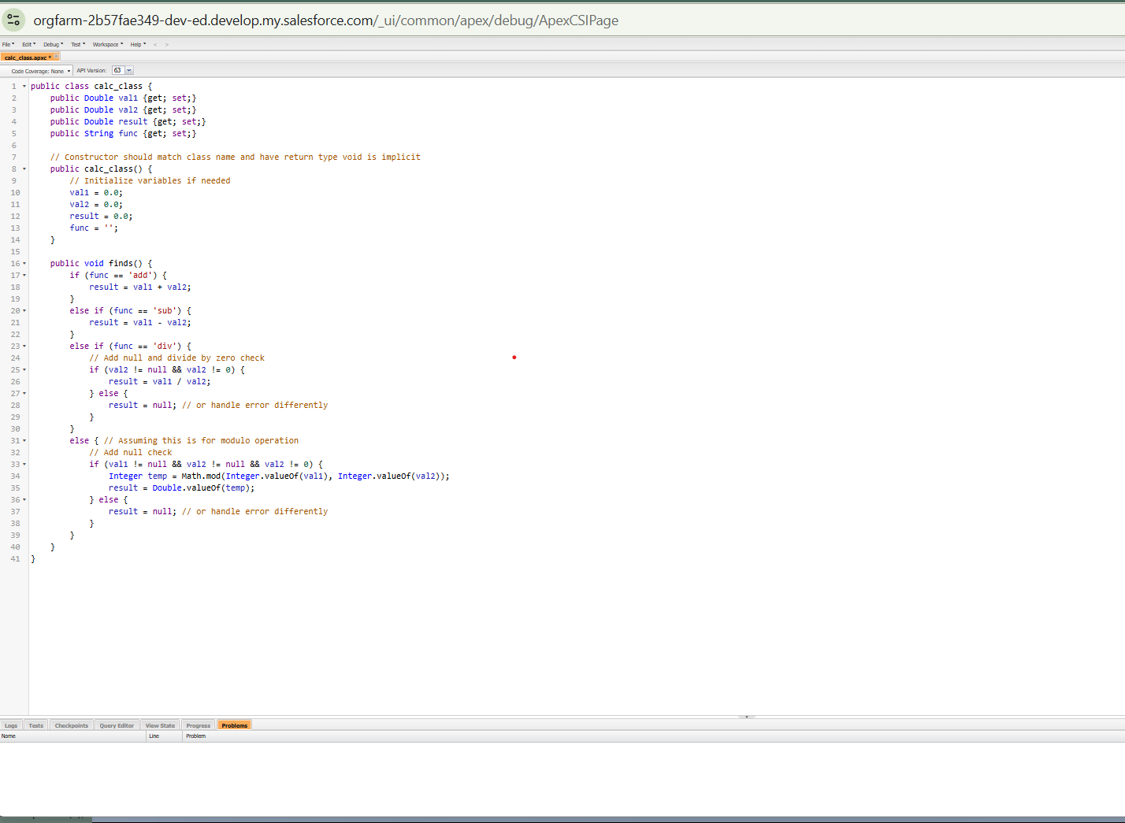

Step 6 : Click on Setup Menu button & Click on Setup

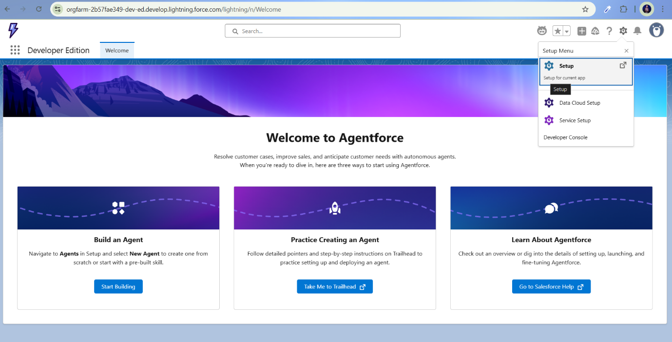

Step 7 : Seach Visualforce Pages in the search bar

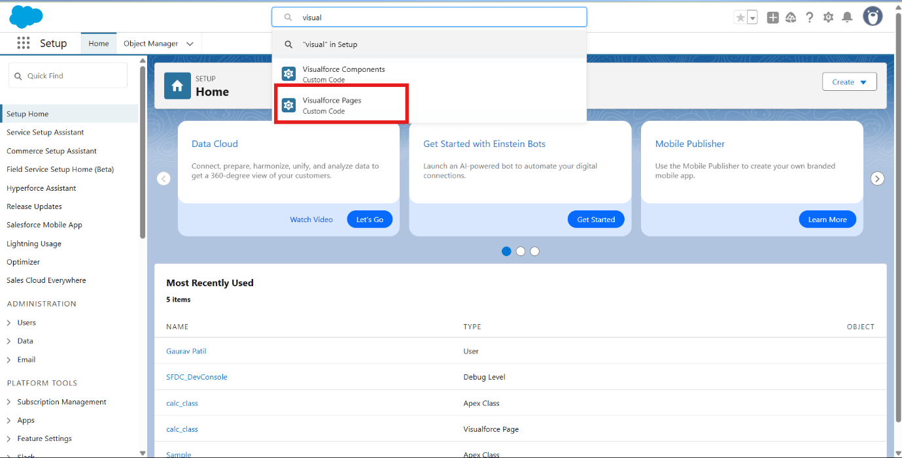

Step 8 : Click on new button

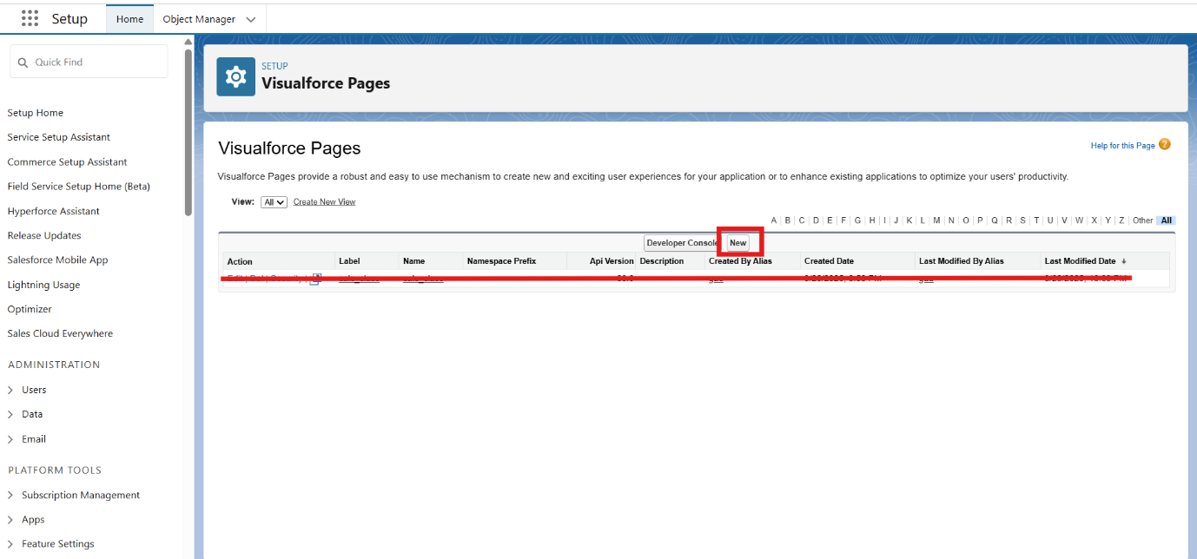

Step 9 : Write label , name & write apex code in the given block

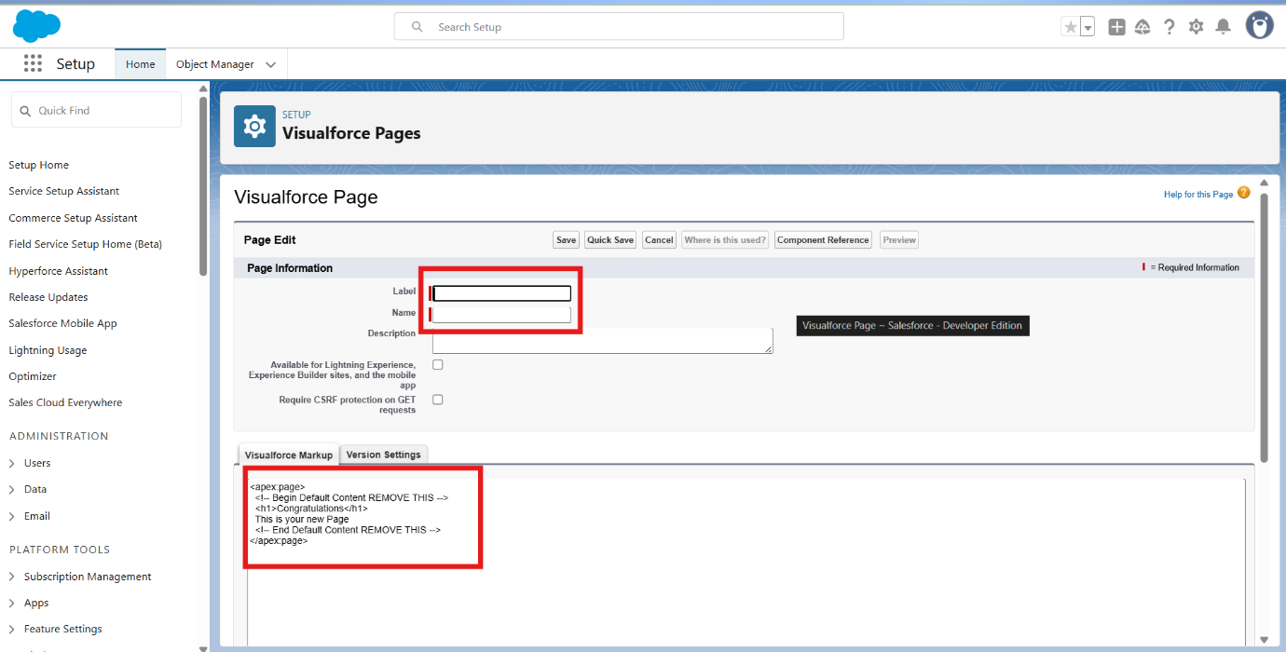

Step 10 : Write this Apex code

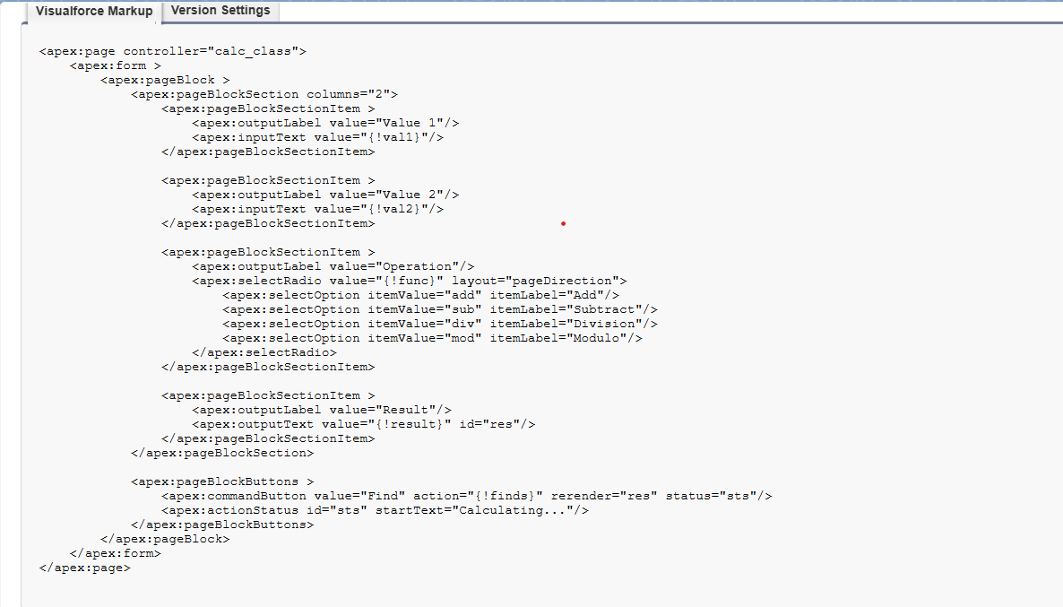

Step 11 : Save & then Click on Preview button

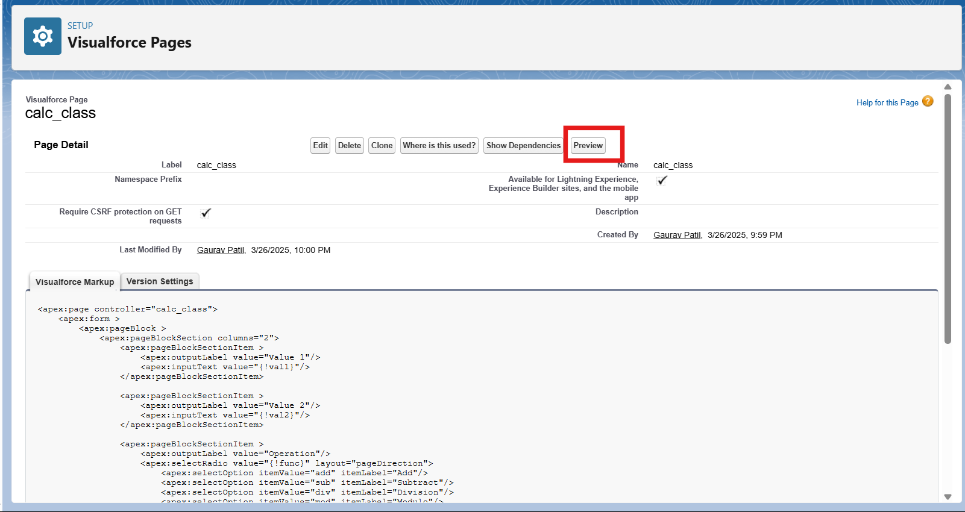

Step 12 : Output , That’s it we are done happy coding !

